A

Project Report On…



***Tea Diary***

Developed By…

***Kapadi Tushar G.***

Submitted To..

**Geetanjali Colleges Of Computer Science And Commerce(BBA)**

Saurashtra University Rajkot

***2024-25***

**Prof. Kishorsinh Vala**

**Acknowledgments**

* First Of All, We Are Sincerely Thanked to Saurashtra University for Giving a Project as A Particular Subject.
* I Am Also Greatly Grateful to Our Geetanjali Group of Colleges. We Would Like to Thanks Prof. Brijesh Shah (HOD) For Providing Us Opportunity to Prepare This Project.
* To Complete This Project Many Persons, Help Me. They Help Me Conceptualized the Idea of The Project and Also Helped Me in Streamline My Work by Providing Me Every Facility Required.
* Not Only College and Guide Help Me but All the Well Wisher Who Gives Me Excellent Support in During Project.
* Thanks To All.

**Your Faith Fully,**

**Kapadi Tushar Govindbhai**

**Preface**



* In This Project is Aimed At Developing a Tea Diary For Tea Seller.It is a Mobile Application That Can Use For Store Record of Ordered Tea,Coffee and etc. By Customer.

* Seller Can Handle Customer,Handle Items And Handle Bills.Seller has Not to Worry About to Write An Order Of Customer on Paper Or Diary.
* The Application’s ultimate goal is to provide Functionalists Like Add Order Detail’s Of Particular Customer,View Order Details,Update or Delete Order Details.Also Generate Bills Of Particular Customer And Store Them Into Mobile’s Storage and Also Share To Particular Customer.

**Index**

**35**

**36**

**37**



|  |  |  |
| --- | --- | --- |
| **SR.NO** | **TOPIC NAME** | **PAGE.NO** |
| **1** | **Project Profile** | **1** |
| **2** | **System Development life Cycle** | **2** |
| **3** | **Project Requirement** | **5** |
| **4** | **Technology Requirement** | **6** |
| **5** | **E-R Diagram** | **7** |
| **6** | **Data Flow Diagram** | **8** |
| **7** | **Data Dictionary** | **11** |
| **8** | **Screenshots** | **15** |
| **9** | **Future requirements of project** | **32** |
| **10** | **Limitation of project** | **33** |
| **11** | **Webilography** | **34** |

Project Profile

|  |  |
| --- | --- |
| **About Project** | **Project Details** |
| Project Name | Tea Diary |
| Project Platform | Android With Kotlin |
| Front-End | XML |
| Back-End | Kotlin |
| Developer Name | Kapadi Tushar Govindbhai |
| IDE Tool | Android Studio Flamingo Version |
| Project Type | Mobile-Application |
| Database | SQLite |
| Project Guide | Prof. Kishorsinh Vala |

# System Development life Cycle

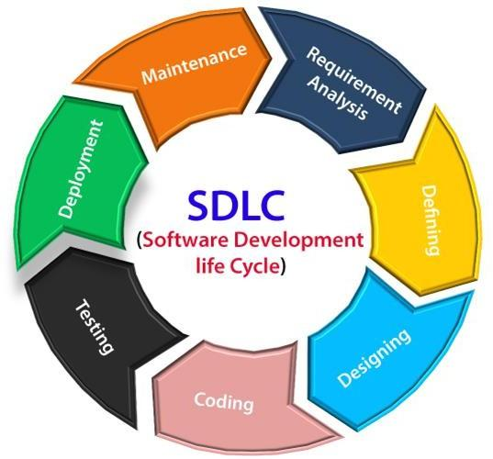

**Initiation Phase:**

* Investigate trends in small business management, seller needs, and digital tools for order and billing management.
* Determine the need for an efficient Tea Diary application to streamline customer and item management, order processing, and bill generation.
* Analyze the shift towards digital records, increasing demand for quick order processing, and secure billing solutions.
* Identify key requirements such as customer management, billing, and sharing functionality.

**Planning Phase:**

* Develop a detailed project plan outlining tasks, timelines, resource requirements, and budget
* Identify key deliverables such as customer management, order management, item handling, and bill generation features.
* Utilize collaboration tools and project management software to facilitate communication and track progress.

**Planning Phase:**

* Collect requirements from tea sellers and small business owners.
* Capture requirements related to performance,scalability, and usability.
* Document features such as customer management (add, remove, update customers), item handling (add, update, delete items), and order management (add order details per customer).Define essential features like:

- Customer management (adding, updating, deleting customers).

- Item management (adding, updating, deleting items).

- Order handling (recording order details per customer).

- Bill generation and sharing functionalities.

**Design Phase:**

* Define the system architecture, including application layers (presentation, business logic, data access) and overall structure.
* Design the database schema to support customer management, item inventory, order processing, and bill generation.
* Design user interfaces with a focus on user experience and accessibility.

**Development Phase:**

* **Server-Side Development:**
* Implement CRUD operations for customers, items, and orders.
* Develop bill generation and sharing functionality.
* **User Interface Development:**
  + Develop the frontend using XML.

**Testing Phase:**

* Perform manual testing and system testing to identify and fix issues.
* Validate customer management, item handling, order processing, and bill generation features.

**Maintenance:**

* Monitor system performance and address any issues that arise.

**Project Requirement**



**PC Requirement(With Android Studio):**

|  |  |
| --- | --- |
| **Ram** | 8GB Ram or more |
| **Hard Disk** | Free Space 500MB |
| **Operating System** | Windows 10 or Greater |
| **IDE** | Android Studio Flamingo Version |
| **Processor** | x86-64 processor (64-bit with Intel core 2 duo, Core i3, Core i5, Core i7, or Xeon processor) |

**Mobile Requirement(When App is on User’s Mobile):**

|  |  |
| --- | --- |
| **Ram** | 2GB Ram or more |
| **Storage** | Free Space 50MB |

**Technology Requirement**

|  |  |
| --- | --- |
| **Programming Language** | Kotlin |
| **Emulator** | Pixel 4 With API 27 |
| **Additional Dependency** | Require Dependency For itext PDF and chrisbanes PhotoView:2.3.0. For PDF Scrolling. |
| **IDE** | Android Studio |

**System Design Tools**

**[ER Diagrams]**

An entity Relationship Diagram (ERD) is a data modeling technique that graphically illustrates an information system’s entities and the Relationship between those entities . An ERD is a conceptual and representation model of data used to represent the entity from work infrastructure.

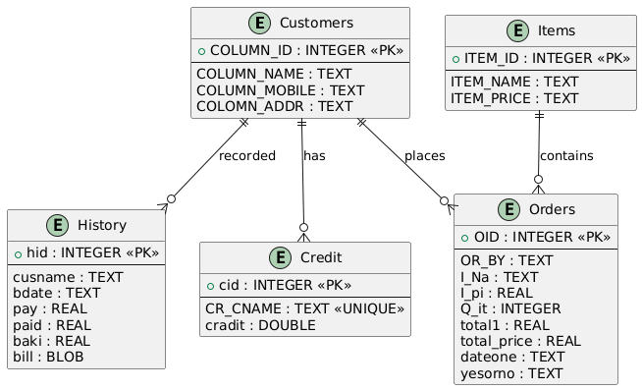

**[DFD’s]**

* **Seller Side:**

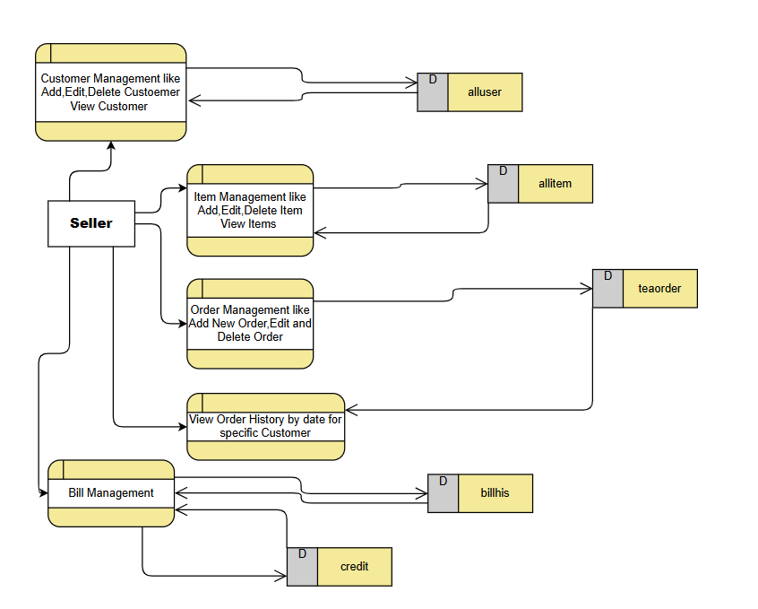

* **Employee side:**

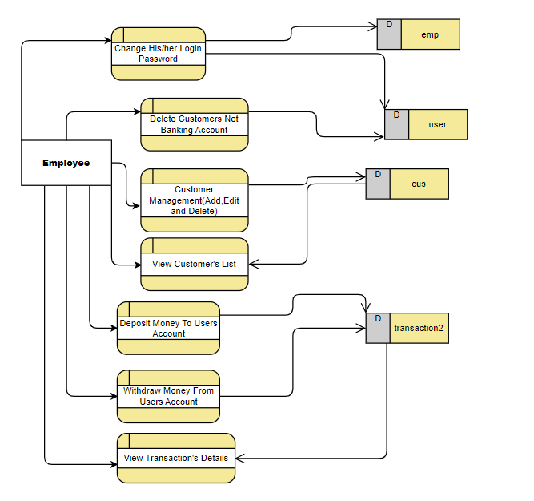

* **Customer side:**

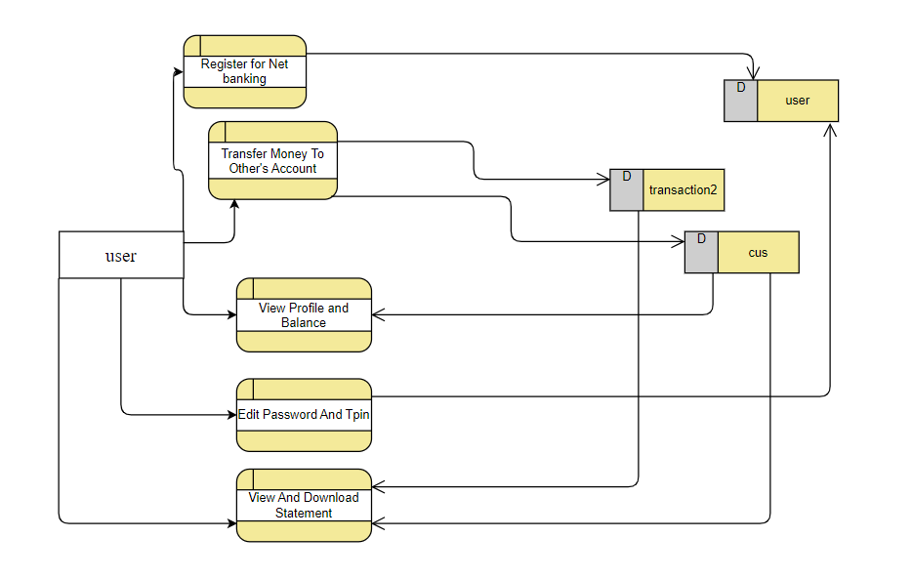

**Data Dictionary**

**Database Name:-**diarytea11

**Data Table:-**

1.alluser

2.allitem

3.teaorder

4.credit

5.billhis

**1.alluser:**

|  |  |  |  |  |
| --- | --- | --- | --- | --- |
| **Column** | **Data Types** | **Size** | **Allow Null** | **Constraints** |
| id | INTEGER | - | No | Primary Key  Auto-increment |
| name | TEXT | - | No | - |
| mobile | TEXT | - | No | - |
| address | TEXT | - | No | - |

**2.allitem:**

|  |  |  |  |  |
| --- | --- | --- | --- | --- |
| **Column** | **Data Types** | **Size** | **Allow Null** | **Constraints** |
| id | INTEGER | - | No | Primary Key  Auto-increment |
| itname | TEXT | - | No | - |
| itprice | TEXT | - | No | - |

**3.cus:**

|  |  |  |  |  |
| --- | --- | --- | --- | --- |
| **Column** | **Data Types** | **Size** | **Allow Null** | **Constraints** |
| id | INTEGER | - | No | Primary Key  Auto-increment |
| order_by | TEXT | - | No | - |
| item_name | TEXT | - | No | - |
| item_quantity | INTEGER | - | No | - |
| item_price | REAL | - | No | - |
| total1 | REAL | - | No | - |
| total_price | REAL | - | No | - |
| dateone | TEXT | - | No | - |
| Y | TEXT | - | No | - |

**4.credit:**

|  |  |  |  |  |
| --- | --- | --- | --- | --- |
| **Column** | **Data Types** | **Size** | **Allow Null** | **Constraints** |
| id | INTEGER | - | No | Primary Key  Auto-increment |
| customer name | TEXT | - | No | UNIQUE |
| cr | DOUBLE | - | No | - |

# 

**5.billhis:**

|  |  |  |  |  |
| --- | --- | --- | --- | --- |
| **Column** | **Data Types** | **Size** | **Allow Null** | **Constraints** |
| id | INTEGER | - | No | Primary Key  Auto-increment |
| cus_name | TEXT | - | No | UNIQUE |
| betweendate | TEXT | - | No | - |
| payable_amount | DOUBLE | - | No | - |
| paid_amount | DOUBLE | - | No | - |
| baki_amount | DOUBLE | - | No | - |
| bills | BLOB | - | No | - |

# Screen Shots

# 1.Seller Dashboard

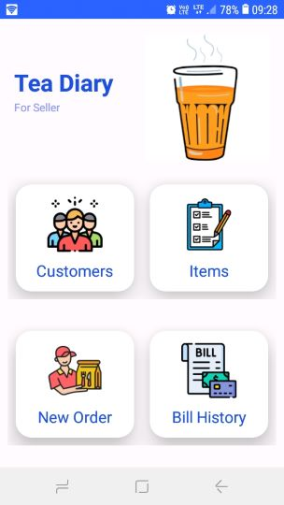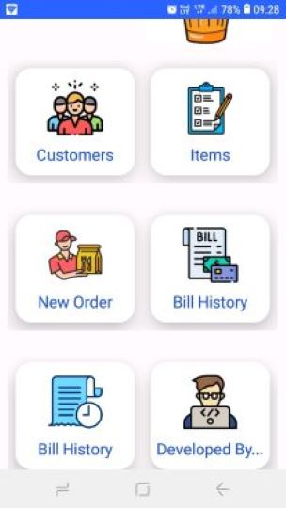

# This is Main Dashboard Activity,Here Seller Can Select Option and Work on them.

* Customers for Customer Management,Items For Item Management,New Order For Add New Order,Bill History For View Order Details And Generate Bill.

# 2.Customers Management

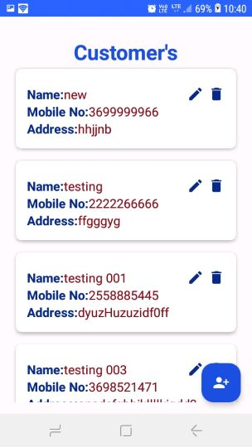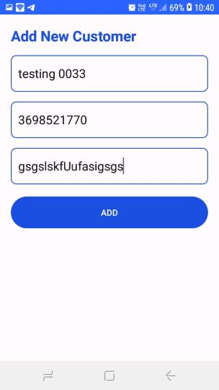

* When Seller Click On Customers Icon,than Customer Dashboard Will Open,Customer Dashboard Display all Customers.
* When Seller Click On Square Button Add New Customer Activity Will Open,Here Seller Can Insert Information About New Customer.

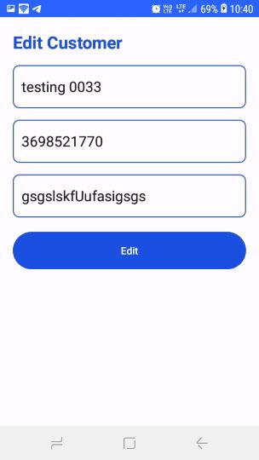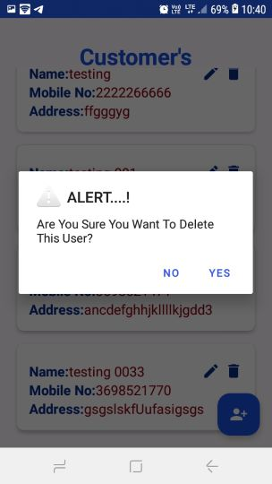

* When Seller Click On Pencil Button,than Customer Edit Activity Will Open,Here Seller Can Edit Information of Customer.
* When Seller Click On Dustbin icon,than one Alert is Display,This Alert Confirms that Seller Surely Delete Customer?
* If Seller Click On Yes Than Customer Will Delete.

# 3.Item Management

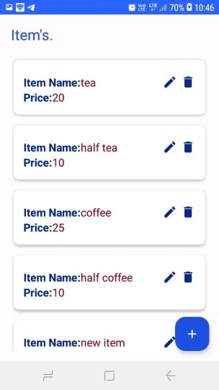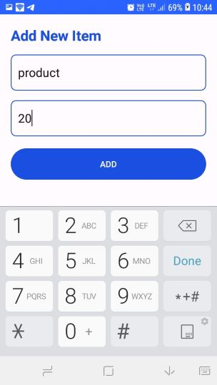

* When Seller Click On Items Icon,than Item Dashboard Will Open,Item Dashboard Display all Items Information.
* When Seller Click On Square Button Add New Item Activity Will Open,Here Seller Can Insert Information About New Item Like Name And Price.

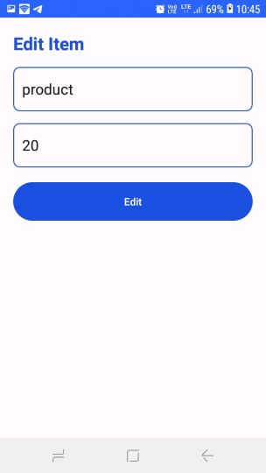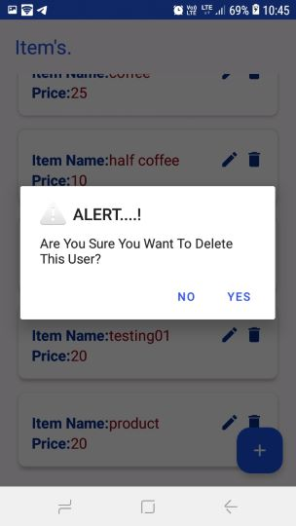

* When Seller Click On Pencil Button,then Item Edit Activity Will Open,Here Seller Can Edit Information of Item.
* When Seller Click On Dustbin icon,then one Alert is Display,This Alert Confirms that Seller Surely Want To Delete Item?
* If Seller Click On Yes Then Item Will Delete.

**4.Add New Order**

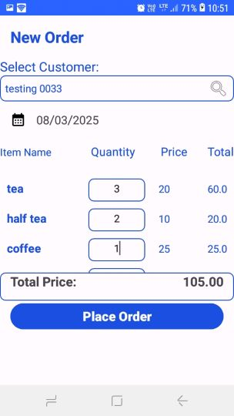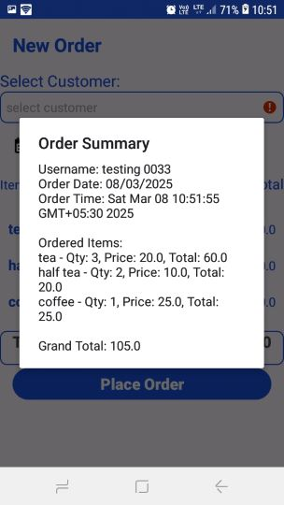

* Here Seller Can Insert New Order Details,Like In Spinner Seller Get All Customer Name And Select One Customer Name.
* Insert Item Quantity,And Get Total Of All Ordered Items.
* When Seller Click on “Place Order” Button,Then Order Summary Will Display.

**5.Order History**

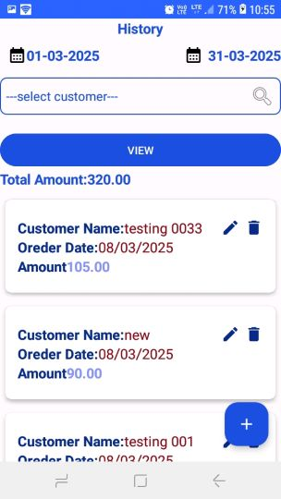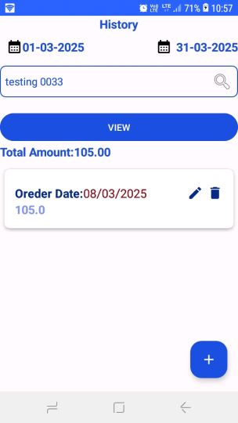

* When Seller Click On Order History Than History Dashboard Will Open.
* If Seller Select “---select customer---” Then All Customers Order History Will Open.
* If Select Particular Customer Then Get All Order History Of Particular Customer.
* When Click On “+” Button,Bill Of Selected Customer Will Generate.
* This Bill Save On Bill History.

**6.Bill History**

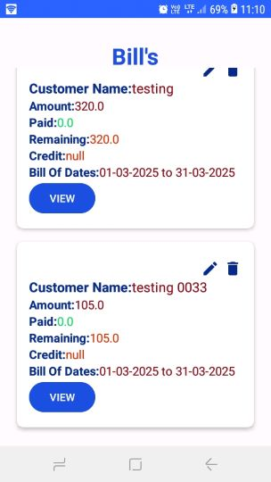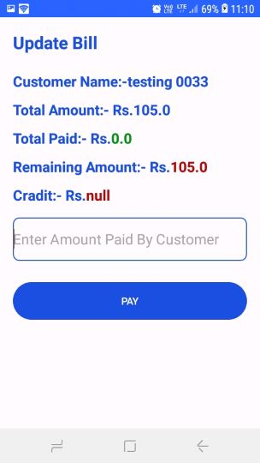

* When Seller Click On Bill History Icon,Then Bill Dashboard Will Open.
* Here Bill Of All Customers Will Display.
* When Seller Click On “VIEW” Button,Particular Customer’s Bill PDF Open.
* When Seller Click On Pencil Button,Update Bill Activity Open And Here Seller Can Add Amount Given By Customer.

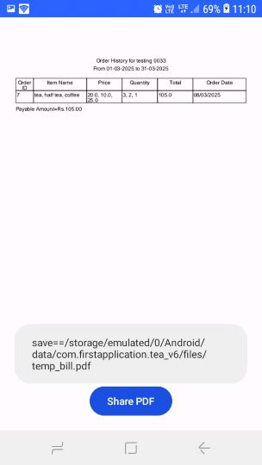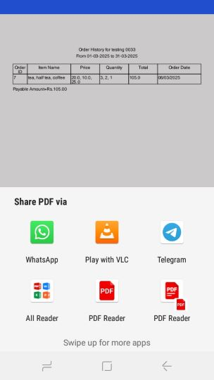

* When Seller Click On “Share PDF” Button,Seller Can Share PDF Via WhatsApp Or etc.

**Future Requirements Of Projects**

* **Provide Firebase Database Service Or REST API Service using PHP Instead Of Sqlite Database For Storage.**
* **UI Improvements.**



**Limitations of Project**

* **If Seller Uninstall Application By Mistake,All Data Are Delete.Seller Can not Get Back Stored Data.**
* **Sellers Need To Insert All Data About Users And Items.**



**Webilography**

* **https://stackoverflow.com/**
* **https://**[**www.javatpoint.com/**](http://www.javatpoint.com/)
* **https://www.w3schools.com/**

